Biblical Literature I—Old Testament—3rd, 6th, and 7th hours
Testing your Knowledge about –Judges—Ruth—Kings of Israel
Please read the following instructions before you click on the hot-link.
1. Right click on the following website and select “Copy Hyperlink”…
“Stump the Shepherd”
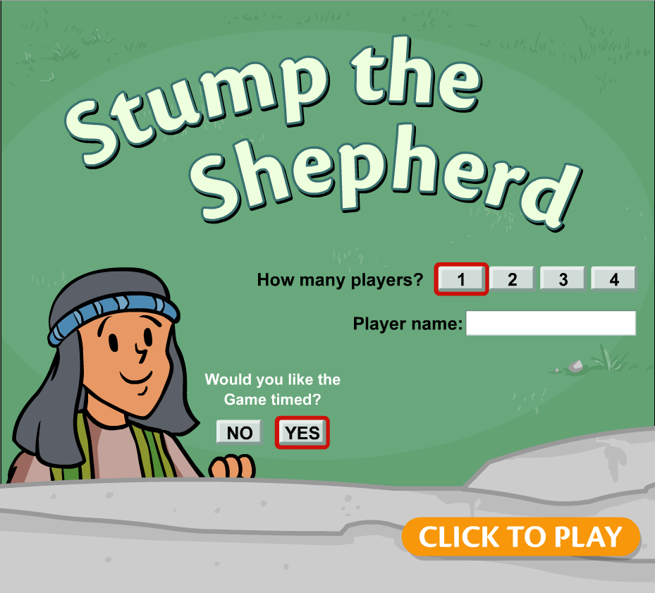

2. Go to FireFox and paste the copied hyperlink in the search bar and click “go”.
3. Four people may play at one time or any combination thereof—you choose.
4. In the “Player” box type in your name(s)
5. Say Yes, to the question…”Would you like the Game timed?”
6. Click to play.
7. Each play then selects his/her shepherd. Then click “done” after your selection.
8. Read the instructions for round one and then click “Let’s Play!”.
9. Note that the time begins.
10. Note that wrong answers will deduct points.
11. You will have 30 seconds to answer your question and if time runs out you will lose points.
12. You may use the Internet to search for answers.
13. Each person needs to keep track of their score.
14. At the end of the game click on the following report form and record your score. Each player will need to click on and report their score.
“Stump the Shepherd” Report Form
15. The category of “Great Gifts” are taken from Roman Catholic teachings so don’t be upset if you don’t know the answer.
16. You may play more than one game with the same players or different one.
17. Have fun with the exercise.

