Biblical Literature II—New Testament
Lesson 3.1 “Herod the Great Hates the Christ Child”

Name: Hour:

1. For a brief introduction to King Herod the Great click on the link.

a. When did King Herod rule over Judea?

b. What is the “slaughter of the innocents”?

c. What is the “other side” of King Herod?

2 Let’s find out more this man.

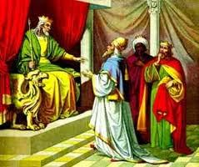
“Herod the Great was appointed king of Judea in 40 b.c. by the Roman senate. He was an able man who accomplished much during his reign. He oversaw many building projects in his own kingdom and abroad—including the rebuilding of the temple
in Jerusalem. But he was also an evil man and a ruthless
ruler, murdering his wife, his sons, and other relatives whom
he thought were a threat to his rule. So when Herod was
confronted by the wise men who wanted to know about the
baby who had been born King of the Jews, Herod
immediately took action.”

Mt 2:3-8

- How did Herod find out about the baby?

- What did the chief priests and teachers tell Herod as to where the Christ would be born?

- Why did Herod ask the wise men about the time when the star had appeared?

- What reason did Herod give for wanting the Magi to report back to him after they had found the Christ Child?

- Verse 3 says that Herod was disturbed at the news of this child. Knowing what you do of Herod, why was he disturbed?

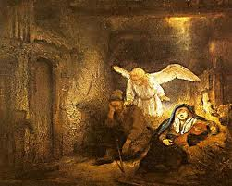
Mt 2:13-18

- After the wise men had left Joseph’s house,
why did the angel tell Joseph to take his
family to Egypt?

- What prophecy did the family fulfill when they fled to Egypt?

- How did Herod respond when the Magi failed to report back to him?

- What prophecy did Herod’s action fulfill?

3. Some questions to ponder!

a. How did God show His grace to King Herod by sending the Magi?

b. King Herod regarded the Christ Child, who was the King of the Jews, as a threat to his power as an earthly king. In what way do some people today regard Jesus as a threat to their power?

c. What do many people today think of Jesus?

d. Herod’s killing of the children in Bethlehem is sometimes called the “slaughter of the innocents”. What slaughter of “innocents” is going on today? Give me more than one
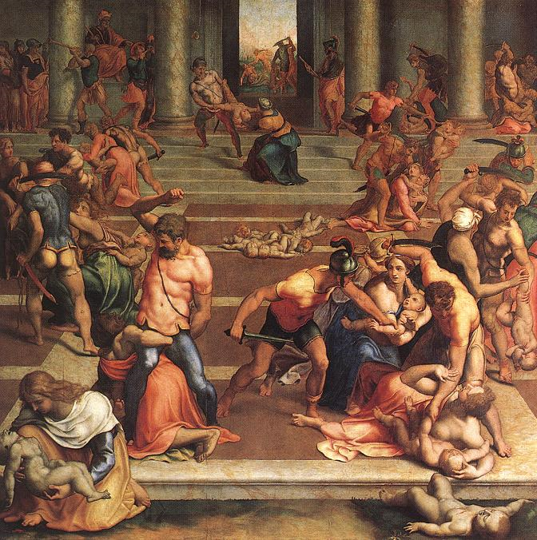
example.

- Now I go back to our website and view
The three videos and see “Genocide” in the
20th Century.

