Biblical Literature II—New Testament
Lesson 2.3 “Christ is the “Light of the World” and of my life!

Name: Hour:

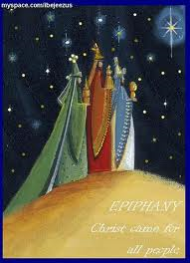
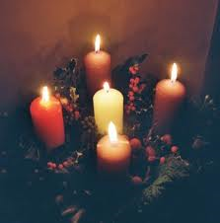
Lights and candles are an integral part of our Epiphany season, because in these seasons we see Jesus as the Light of the world. Consider the reading from Isaiah 60:1-6, the traditional Old Testament reading
for the festival of the Epiphany.
Go to www.biblegateway.com and
look up and read Isaiah 60:1-6.

1. Tell me why this selection of
Scripture is a great reading for the
Epiphany season?

2. Why do you think God uses the concept of “light and darkness” to
describe spiritual things or our walk of faith?

3. Explaining Isaiah 60:1-6 with pictures and Word:

I want you to create a presentation from the following website http://www.sliderocket.com/ with the following guidelines:

- On the “sliderocket” website sign up for a free account.

- View one of the tutorials to see how the website works.

- Create a presentation.

d. Find pictures that explain or illustrate each of these six verses.

e. Place the pictures on a slide and include the verse written out onto the slide as well.

f. You will have one slide for each verse plus a title slide for a total of seven (7)
slides.

g. Be creative in your choice of pictures, slide background color, and font style, size and color.

h. Include music with your presentation.

- Save your presentation (often).

- When you are satisfied with your presentation then “publish” it and copy the “embed” code and the “public link” in the space below.

My “Embed” code is…

My “public link “ is…

- Do a “save as”, use your name as the file name and save this document not only in your file folder but also in the your class hour file folder entitled “001 Isaiah 60”.

l. Enjoy creating your presentation and do it to the “Glory of God”!

