Biblical Literature II—New Testament
Unit 1 Lesson 2.2 “The Gift of the Magi”

Name: Hour:

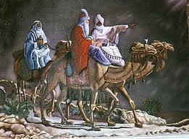
Click on the link and read/listen this special story for Christmas “The Gift of the Magi” by O’Henry (William Sydney Porter). After your read/listen to the story respond to the questions below.

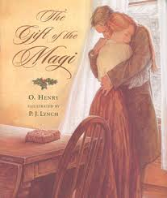

1. First of all in this short story “the number three (3)
figures prominently”. Make a list of the three motifs.

a. For example: The story has three characters:
Della, Jim, and Madame Sophronie.

b.

c.

d.

e.

f.

g.

h.

i.

j.

k.

2. Why might the use of the “three motifs” be a great idea when dealing with the Christmas story?

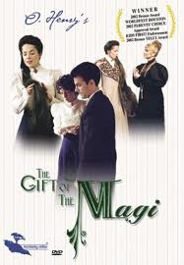
3. Tell me what you think about “Della”.

4. Now tell me what you think about “Jim”.

5. How is this short story a real “love story”?

6. Give an example of:

a. An alliteration…

b. A simile…

7. “Three times in the story, the narrator mentions the “chops” that the Youngs will be having for dinner. How might the “chops” be a significant part of the story?

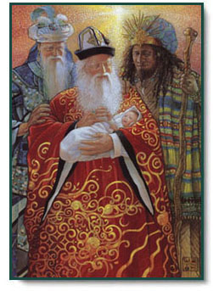
8. Why do you think O’Henry chose the title
“The Gift of the Magi”?

9. What does this story have to do with you?

10. What does this story have to do with the “greatest gift”
you’ve ever received?

11. What is your response to this “greatest-of-all gift”?

