Biblical Literature II—New Testament

Unit 6 “Lessons in Living the Christian Life”

Lesson 05 “Meet the Unholy Trinity”

Name: Hour:

As Christians we need to understand that self-righteousness within and false teachers without are two serious enemies of our faith. But they are just the servants of the three major enemies of our faith, sometimes called the “Unholy Trinity”, which plague our faith from cradle to grave. You see the three named below. **Right Click** on each picture to see what it is, what it means and how it affects us. Remember that as we fight this evil horde we are not defenseless for in Christ we wear the full armor of God.

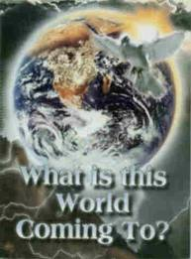

[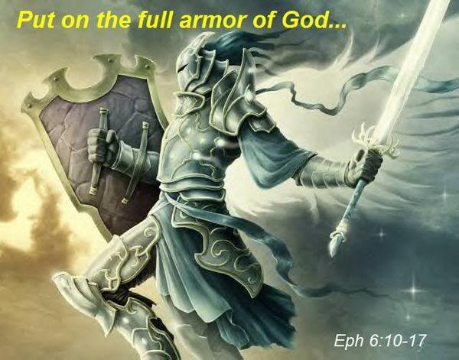](http://youtu.be/DMZ8D6nTKhg)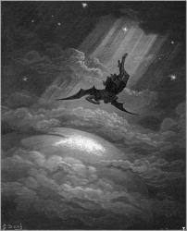

Biblical Literature II—New Testament

Unit 6 “Lessons in Living the Christian Life”

Lesson 05 “Meet the Unholy Trinity” 01Worksheet

Name: Hour:

**This World’s Prince—Our First Enemy of the Unholy Trinity!**

The prince of this world, Satan, is a formidable enemy of our faith. But who exactly is he? Read the following Bible passages, and answer the questions to find out who the devil is, where he came from, and what his future looks like.

[Read 2 Peter 2:4](http://www.biblegateway.com/passage/?search=II%20Peter%202:4&version=GW)

1. What did Satan and his evil angels do?

2. How is his and the evil angels limited power described?

[Read Jude 6](http://www.biblegateway.com/passage/?search=Jude%206&version=GW)

3. What change of residence did Satan and his angels make?

4. Why did they fall?

[Read 1 John 3:8](http://www.biblegateway.com/passage/?search=I%20John%203:8&version=GW)

5. How can we sum up the devil and his work in one word?

6. How long has the devil been at his work?

7. For what reason did the Son of God/Jesus the Christ come into this world?

[Read Revelation 12:9](http://www.biblegateway.com/passage/?search=Revelation%2012:9&version=NIV)

8. How can we link the devil/Satan back to the Garden of Eden?

9. What is the devil’s goal?

[Read Genesis 3:1-6](http://www.biblegateway.com/passage/?search=Genesis%203:1-6&version=GW)

10. What three things did the devil say that put his plan (to lead all astray) into action?

a.

b.

c.

11. And so what did Eve do?

[Read Job 1:7](http://www.biblegateway.com/passage/?search=Job%201:7&version=GW)

12. What does God still permit Satan to do?

[Read 1 Peter 5:8](http://www.biblegateway.com/passage/?search=I%20Peter%205:8&version=AMP)

13. What does the devil do as he roams the earth?

**a.**

**b.**

14. What is our responsibility in dealing with these attacks of the devil?

**a.**

**b.**

**c.**

[Read John 8:44](http://www.biblegateway.com/passage/?search=John%208:44&version=GW)

15. Why can’t the devil be trusted?

[Read Ephesians 6:11-12](http://www.biblegateway.com/passage/?search=Ephesians%206:12&version=GW)

16. What must we admit about Satan?

[Read Ephesians 2:1-2](http://www.biblegateway.com/passage/?search=Ephesians%202:1-2&version=AMP)

17. Who are the devil’s supporters, whether they know it or not?

[Read Revelation 12:10](http://www.biblegateway.com/passage/?search=Revelation%2012:10&version=NIV)

18. What does the devil do after we have sinned?

[Read Matthew 16:18](http://www.biblegateway.com/passage/?search=Matthew%2016:18&version=AMP)

19. No matter how powerful Satan is, what can he never do?

[Read Matthew 25:41](http://www.biblegateway.com/passage/?search=Matthew%2025:41&version=AMP)

20. What was prepared for the devil?

[Read I John 4:4](http://www.biblegateway.com/passage/?search=1%20John%204:4&version=CEV)

21. What is reassuring to know as we do battle with Satan?

New Testament • Unit 6 “Lessons in Living the Christian Life” Lesson 05 • Copy Master 15

Back to Lesson 05

Biblical Literature II—New Testament

Unit 6 “Lessons in Living the Christian Life”

Lesson 05 “Meet the Unholy Trinity” 02 Worksheet

Name: Hour:

The second enemy in the unholy trinity surrounds us on all sides. Jesus repeatedly warned his disciples about the dangers of this enemy.

[Read Matthew 18:7](http://www.biblegateway.com/passage/?search=Matthew%2018:7&version=AMP)

1. Which enemy does Jesus name and condemn with the word “woe”?

2. What does this second enemy do to us?

3. Make a list of what the second enemy might use to do its ugly job.

a.

b.

c.

d.

[Read Luke 21:9-11](http://www.biblegateway.com/passage/?search=Luke%2021:9-11&version=NIV)

4. Here Jesus is warning his disciples about the end of the world. What other aspect of the world

can tempt us to sin and even to forsake our faith?

[Read Luke 21:12-19](http://www.biblegateway.com/passage/?search=Luke%2021:12-19&version=NIV)

5. What may the world of unbelievers do to us that may threaten our faith?

**a.**

**b.**

**c.**

**d.**

**e.**

6. What is the encouragement from Christ for us?

a.

b.

[Read Matthew 24:12-13](http://www.biblegateway.com/passage/?search=Matthew%2024:12-13&version=NIV)

7. What will increase more and more as the end approaches, again tempting us to sin and forsake the faith?

a.

b.

8. Yet through it all what do we know?

New Testament • Unit 6 “Lessons in Living the Christian Life” Lesson 05 • Copy Master 15

Back to Lesson 05

Biblical Literature II—New Testament

Unit 6 “Lessons in Living the Christian Life”

Lesson 05 “Meet the Unholy Trinity” 03 Worksheet

Name: Hour:

The Pharisees emphasized outward obedience to the law, especially to their own man-made traditions, which went above and beyond what God required. In the following passage from Mark, the Pharisees had condemned the disciples for eating their food with unclean hands. Now Jesus tells the Pharisees what is truly clean and unclean in God’s eyes and we are introduced to our third enemy—**ourselves!**

[Read Mark 7:14-15,20-23](http://www.biblegateway.com/passage/?search=Mark%207:14-15,%2020-23&version=NIV)

1. What makes people truly unclean?

2. What comes out of our hearts that makes us unclean?

a.

b.

c.

d.

e.

f.

g.

h.

i.

j.

k.

l.

m.

3. What is true about every single sin we commit?

4. What conclusion can we draw about our nature?

New Testament • Unit 6 “Lessons in Living the Christian Life” Lesson 05 • Copy Master 15

Back to Lesson 05