Biblical Literature I—Old Testament
Unit 6 “The Time of the Kings”
Lesson 03 “Saul Slips and its Costs!” Worksheet

Name: Hour:
Introduction: “The cost of it all!!”
a. What are some of the costs of owning a home?

b. What are some of the costs of owning an automobile?

c. What are some of the costs of owning a cell phone?

Today in our lesson we will discover what is involved in the “cost” of not being faithful to God and yet He is faithful to us.
Read I Samuel 12:1-25
1. Samuel begins his farewell speech to the nation of Israel…
a. What is the first things that Samuel wants Israel to understand about his ministry among them?

b. Samuel then gives Israel a history lesson…
1) Which four judges does he mention?
Aa.
Bb.
Cc.
Dd.
2) What did Israel want when they “saw that Nahash king of the Ammonites was moving against them”?

c. What will happen to Israel if they and their king doesn’t “obey the Lord and they rebel against his commands”?

d. What did Samuel “call upon” to drive home his point and to show the people of the Lord’s power?

e. After experiencing the storm to what did Israel admit?

f. What truths does Samuel share about “useless idols”?
a.
b.
c.
g. How is Israel to “fear the Lord and serve Him”?

h. What will happen if they persist in doing evil?

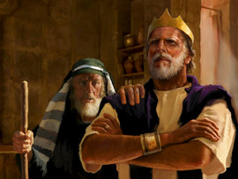
Read I Samuel 13:1-23
2. How old is Saul when he begins his reign as the King of Israel?

3. Saul gathers a small army and attack the Philistine outpost at Geba. The Philistines hear about it and what does Saul announce that Israel became to Philistines?

4. What did the men of Israel do when they saw the approaching Philistine army?

5. What was the condition of Saul’s army at Gilgal?

6. Samuel told Saul to wait for him to come to Gilgal to offer up a sacrifice to God and to seek His will and way. When is it hard to be faithful to God?
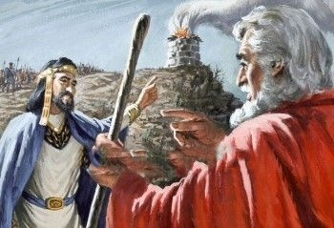
7. What “foolish” thing does Saul do at Gilgal?

8. What happens right after Saul does his “foolish” deed?

9. What were the consequences of Saul’s foolish action?
a.
b.
c.
10. To further compound the “foolish act” of Saul…
a. What could not be found in the whole land of Israel?

b. Why was this such a problem?

c. What weapons did Israel have to use to fight the Philistines?

d. Who were the only men of Israel who had a sword or a spear?

11. Jonathan and his sword-bearer begin the battle and Philistines panic and begin to retreat. Saul sees the retreat and summons his army to chase the Philistines. According to I Samuel 14:23 what was the battle’s result?

Read I Samuel 14:24-52
12. What is the second foolish thing that Saul does?

13. Explain why this was such a foolish thing for Saul to make?

14. Who doesn’t know about the oath and what does he do and what was the results?
a.
b.
c.

15. What happened to the troops when they were exhausted and “pounced on the plunder and, taking sheep, cattle and calves..”?

16. Saul determines that his son Jonathan was the one who broke his oath of not eating. What does Saul want to do?

17. How is Saul stopped from killing Jonathan?

18. This chapter closes with the listing of Saul’s family.
a. How many children does he have?

b. How many wives does he have?

c. Who is the commander of his army?

19. What did Saul do whenever he saw a “mighty or brave man”?

Read I Samuel 15:1-35 “The Lord Rejects Saul as King”
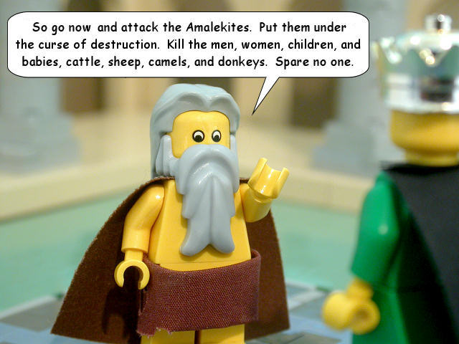
20. Samuel now gives Saul a message from the Lord about the nation of the Amalekites.
What did the Lord tell Saul to do to them?
a.
b.

c.

21. So Saul goes and attacks the Amalekites and what does he do?
a.
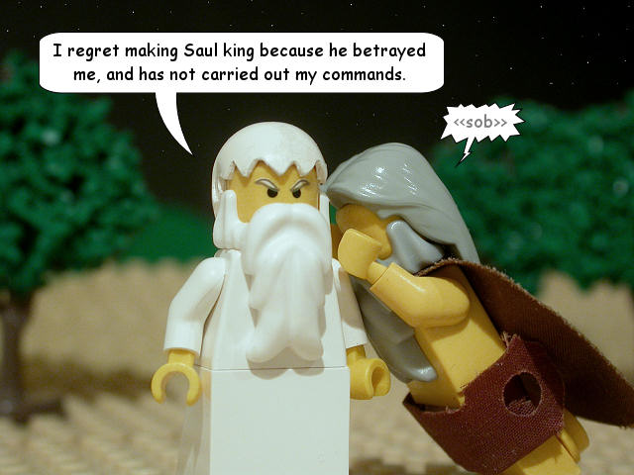
b.
22. God speaks to Samuel about what Saul did and what did God conclude?

23. Look up the word “grieved” and tell me what it means.
a. American Heritage Dictionary…

b. Random House Dictionary…

c. Cambridge Dictionary…

24. Samuel goes looking for Saul and hears that he has gone to Carmel to do another “foolish” act. What was it?

25. Samuel catches up with him at Gilgal. About what does Saul lie to Samuel?
a.
b.
c.
d.
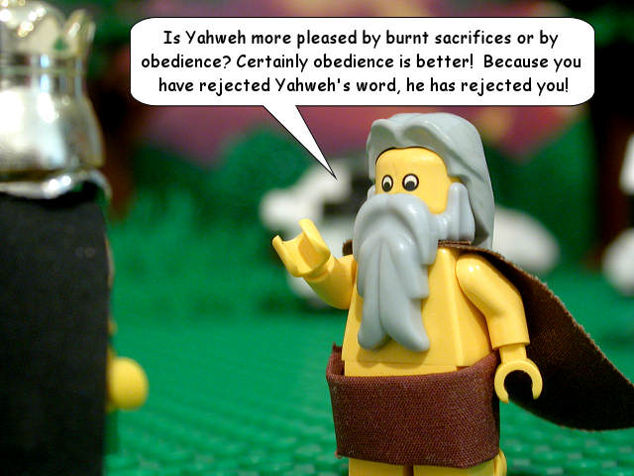
26. What does Samuel tell Saul about what the Lord values the most?

27. What was the result of Saul “rejecting the word of the Lord”?

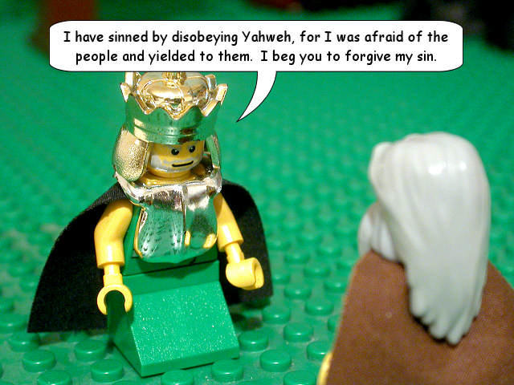
28. To what does Saul admit?

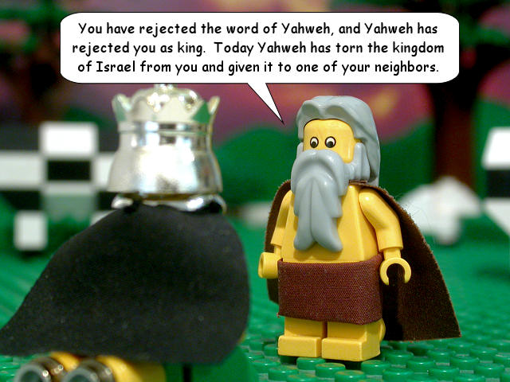

29. What does Saul do as Samuel turns to leave?

30. What did Samuel say Saul’s action meant?

31. What does Samuel tell us about God’s “mind”?

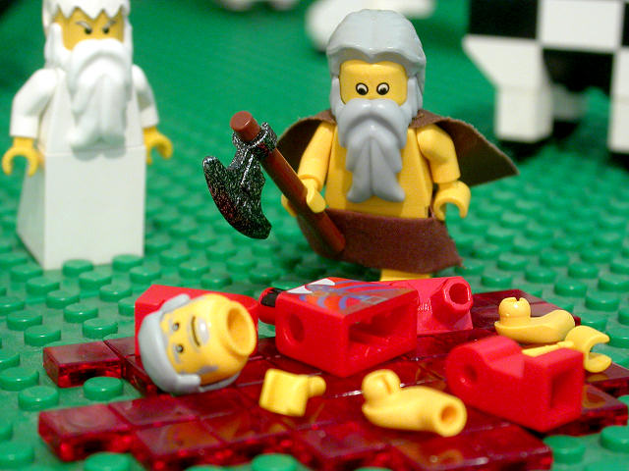
32. What did King Agag think when he was called to appear before Samuel and Saul and what really happened?

33. What never happened again as long as Samuel was alive?

34. What was the Lord’s concluding thought of this chapter?

Application:
35. What does it “cost” us to follow Jesus?

36. What does it “cost” us if we are not faithful in our following Jesus?

37. Should the Lord overlook a few minor things if we largely accomplished what He wanted? Why or why not?

