Topics of Social Science—Freshman Religion
Freshman First Semester Final

1. Click on the following link http://quizstar.4teachers.org/index.jsp . Click on the “Student Login Page” student site button and login in. If you forgot your login information then look on the next pages for your “username”. Your password is “15(first initial and last name). After you have logged in then open the quiz entitled Freshman First Semester Final. Complete the final and submit it.

Note that for the short answer section you are only required to respond to any four (4) of the six. You may do more for extra credit.

May God go with you as you under take this final.

Class Username Login for Freshman First Semester Final
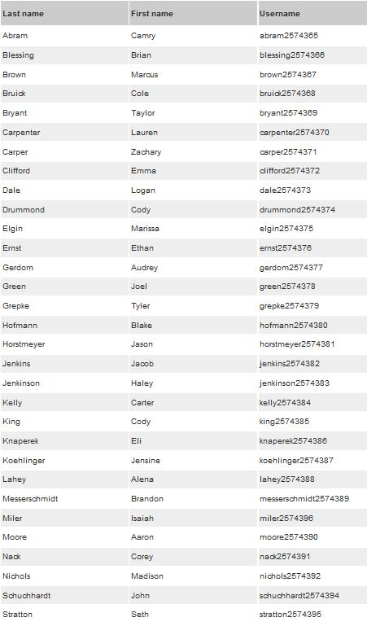
Third Hour UserNames:

Fourth Hour UserNames
Blosser Emma-Marie blosser2574551
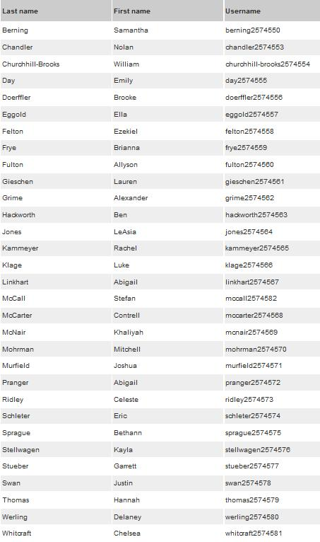

Sixth Hour UserNames

