Class Username Login for Copyright Quiz

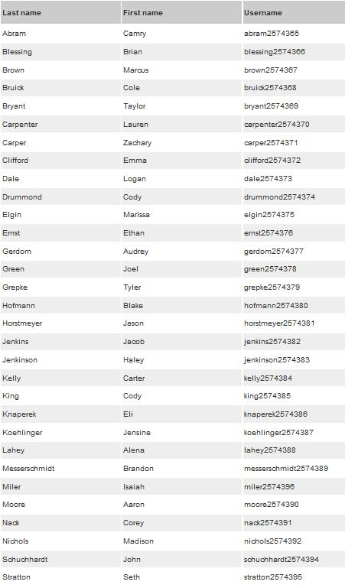
Third Hour UserNames:

Fourth Hour UserNames
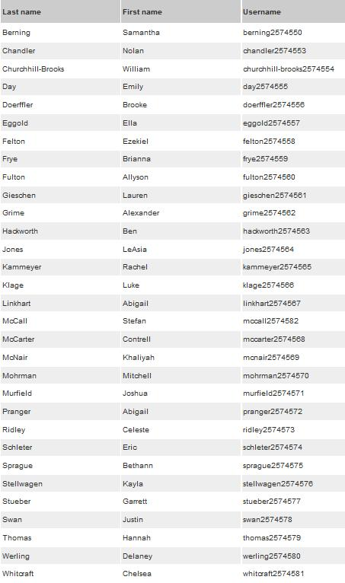

Sixth Hour UserNames
