Privacy and Digital Footprints
01 Trillion Dollar Footprint
Name: Hour:

Introduction:

1. Time for another quickie survey. Click on the link and do your best.

2. Whatever we do on the Internet we are leaving a “trail”. This “trail” is called a “digital footprint” and it is made up of bits and pieces of information on one’s computer and on other computers and servers around the world, which allow other people to learn about you.

3. View the video, Student Intro Video—The Digital Footprint.

What were the “images” that were used to explain our privacy or lack thereof on the Internet? What did each mean?

a.

b.

c.

d.

e.

f.

4. Pick a Host:

Directions:

Today you’re all producers for “Trillion Dollar Footprint”, a popular TV show that tours the country looking for teens to compete in a nationwide talent show. You’re looking for a new host for the show. Based on personal statements from several applicants, you have narrowed the candidates to two: Linda and Jason.

The executive producer has hired a private investigator to dig up whatever he or she can about the candidates online. The PI has created a profile of both of the final candidates with the most important online documents he could find. He has passed along these profiles to you. Based on these profiles, the executive producer wants you to choose which candidate should host the show. You should be very careful how you choose. Your candidate will be seen by millions of teens, so you should make sure that she or he, in particular:

- Works well with others
- Is honest

1. look carefully through the profiles of both candidates.
2. Highlight the information you think is most important, given that you are looking for someone who works well with others and is honest.
3. Fill out the Feedback Form on each host to help you decide which one you will hire.
4. Be prepared to present your selection to the rest of the class, along with specific supporting evidence!

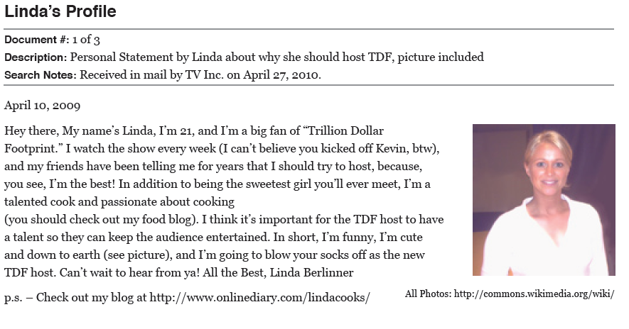
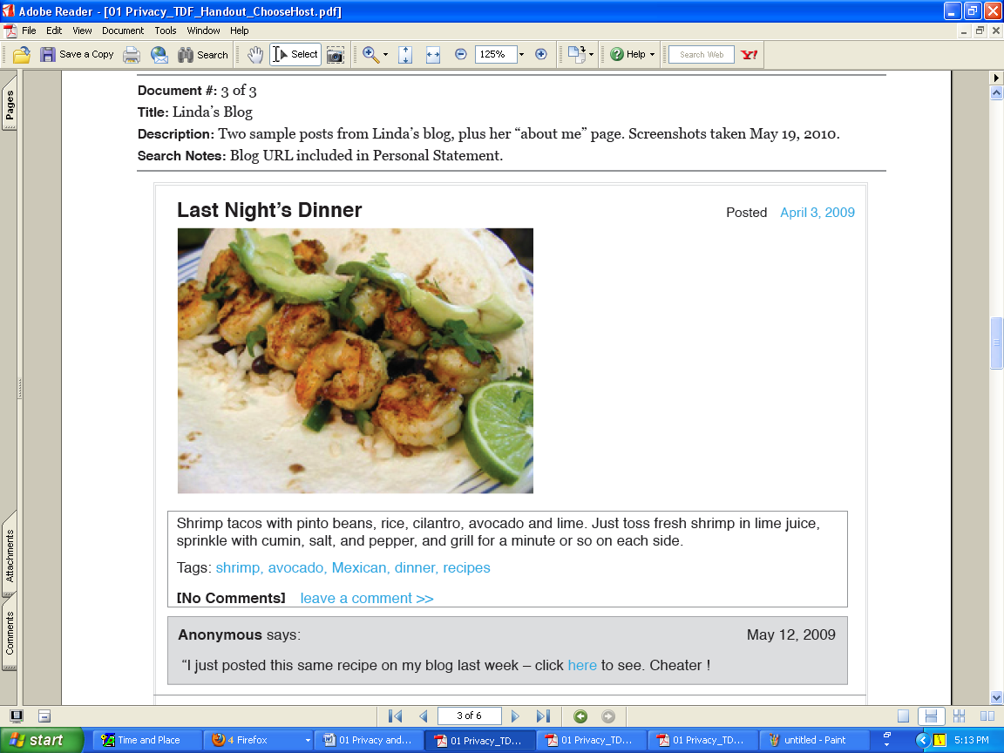
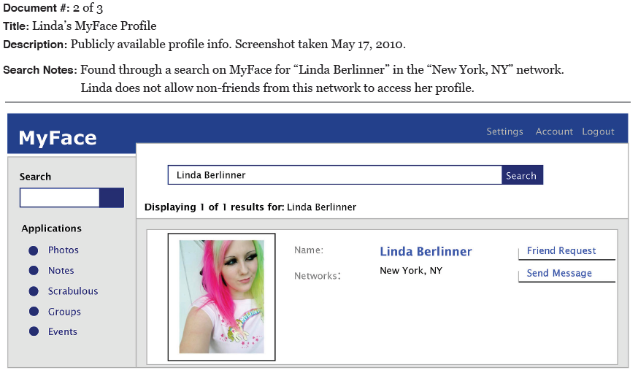
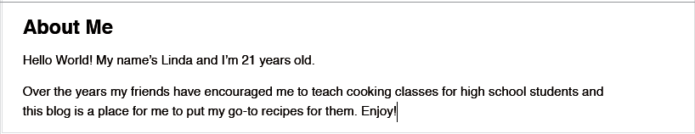
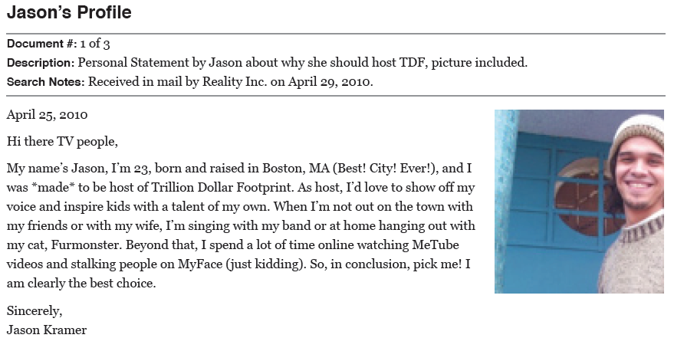
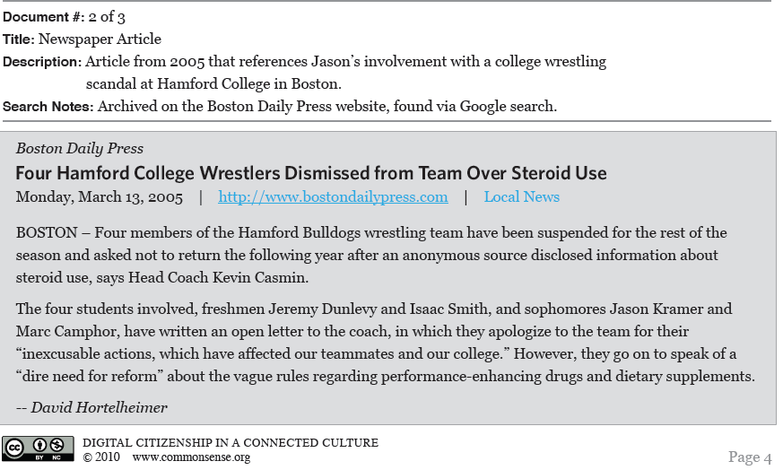

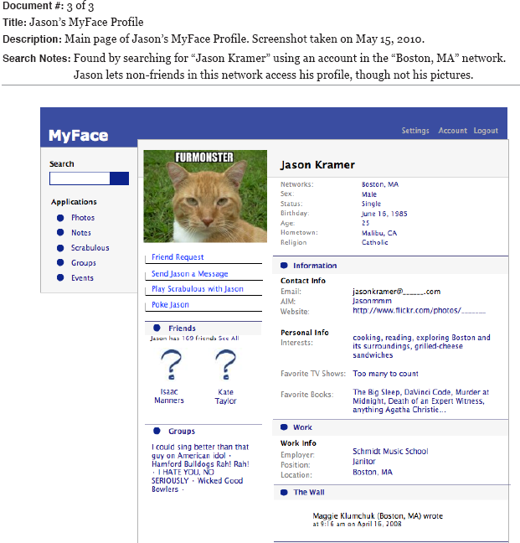

5. Feedback Form:
Selection Criteria: List the pieces of evidence from the profiles that demonstrate the candidate does or does not have each of these characteristics.
Linda Berlinner Jason Kramer
Works well with others

Is honest

My Final Choice is…
Main Reasons for my Choice:
1.
2.
3.

6. My Digital Footprint:

Directions:
What kind of online information would you want linked to your name in 10 years? Design your own digital footprint! Fill in the footprint below with images, Web hits, and types of information that you would want to see linked to your name in 10 years. Examples: “a social networking profile on Facebook or MySpace; a YouTube video of me performing with my rock band; an online newspaper article about my work to help the homeless.” Be creative!

7. Use Common Sense!

You can have a great time online learning from and sharing with others, but:
- Think before you post, because many things you do online will add to your digital footprint
- Remember to review your privacy settings
- Perform a search on yourself every so often to see what your digital footprint looks like

8. Our Christian Dimension…

How do the following Bible passages speak to this “digital footprint” concept?

- Genesis 3:1-9…

- 2 Samuel 11:1-26…

- Philippians 4:8-9…

